**Spring Doc -Referred SreenuTech Videos**

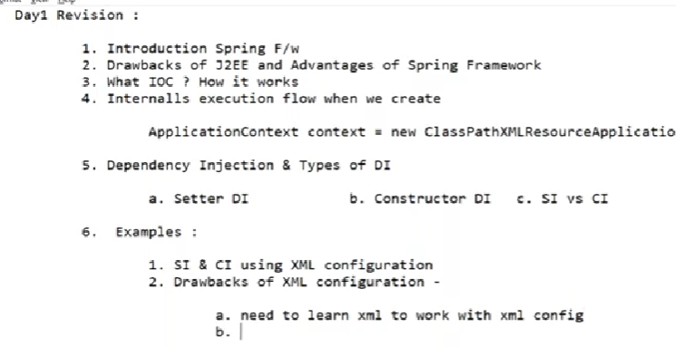

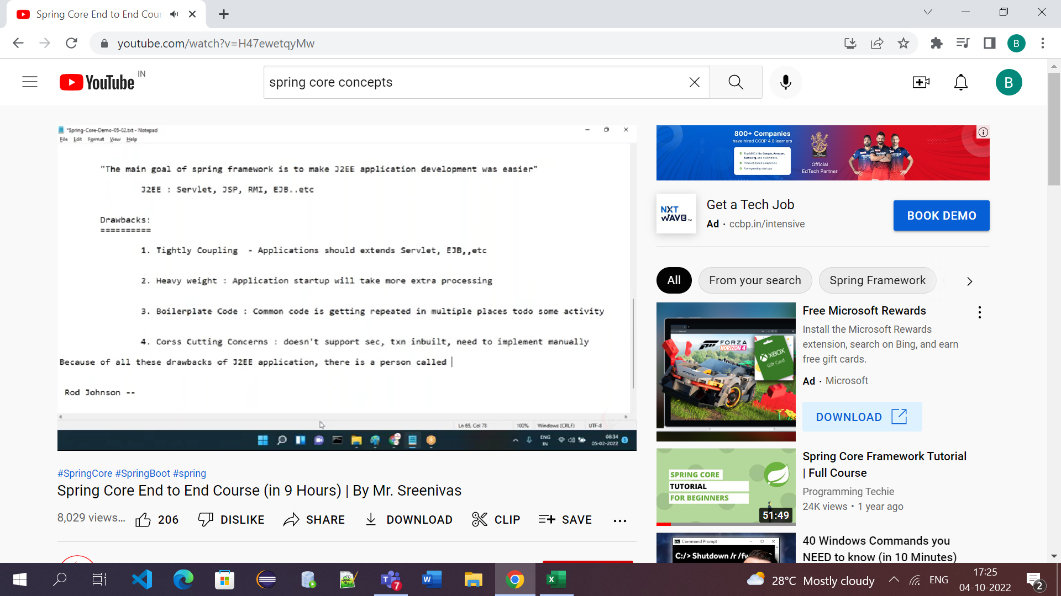

Sec – security

Txn – transactions

2. 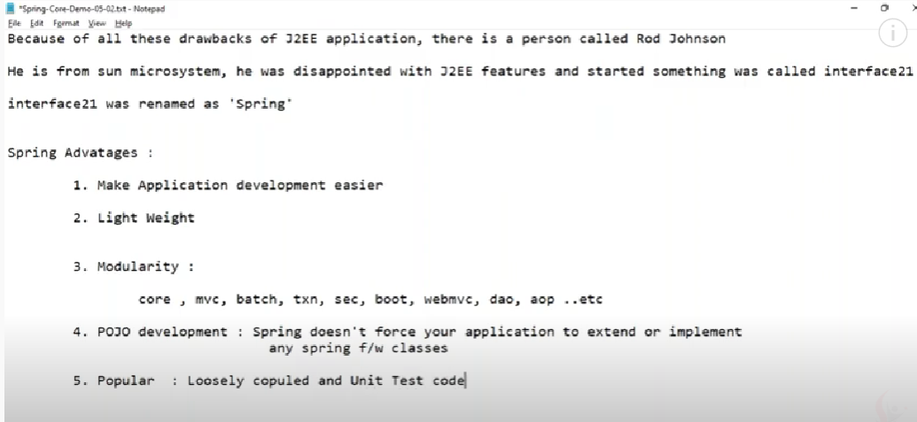

*If we are developing mvc applications we can directly use mvc module similarly other modules

POJO : Spring don’t want your appliction to extend or implement any spring framework classes.

It means migrating to other framework is easier bcz of this rule(POJO)

3. 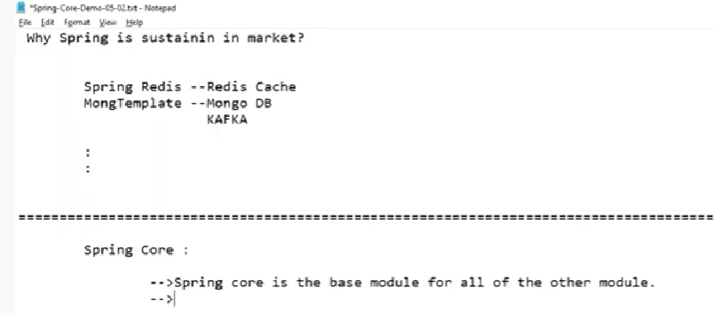

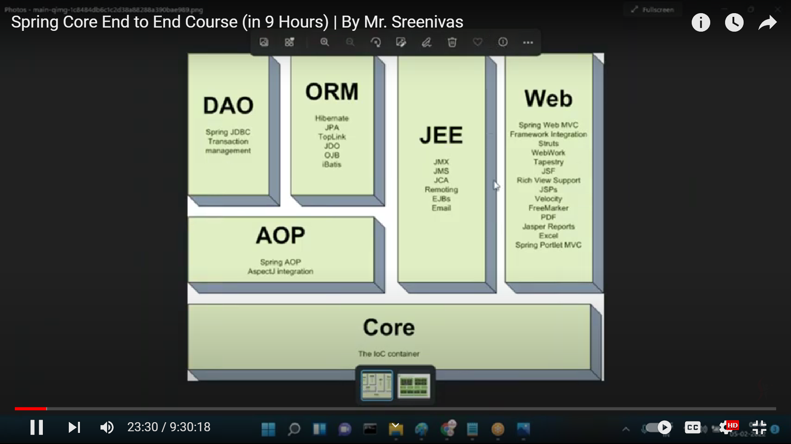

Spring Core

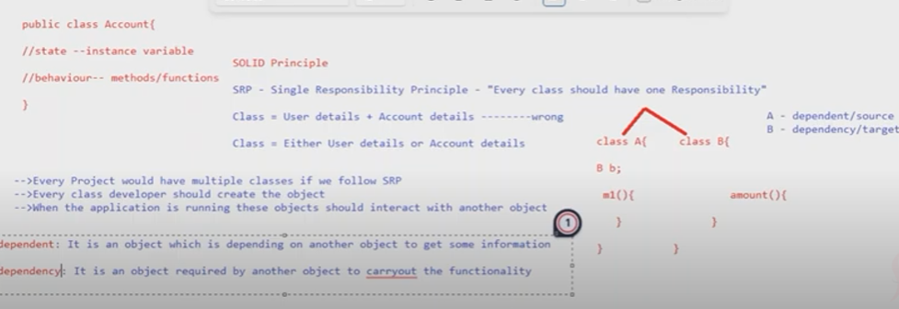

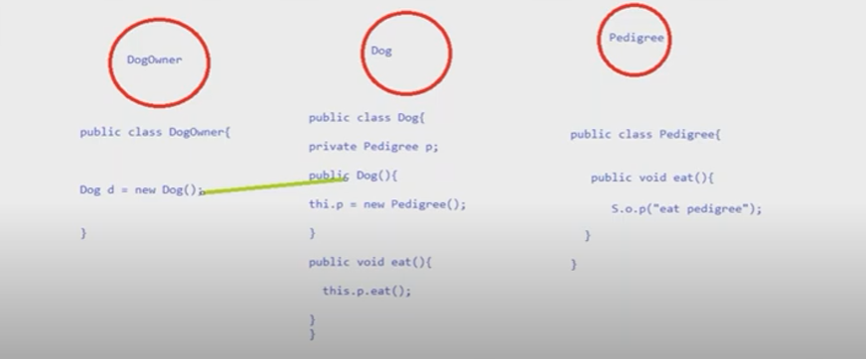

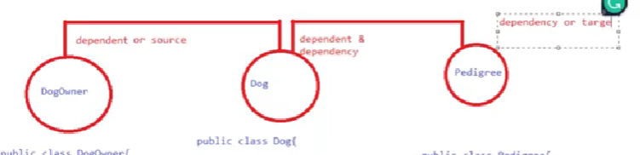

Dependency Injection: 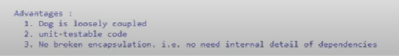

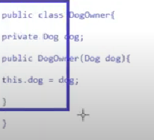

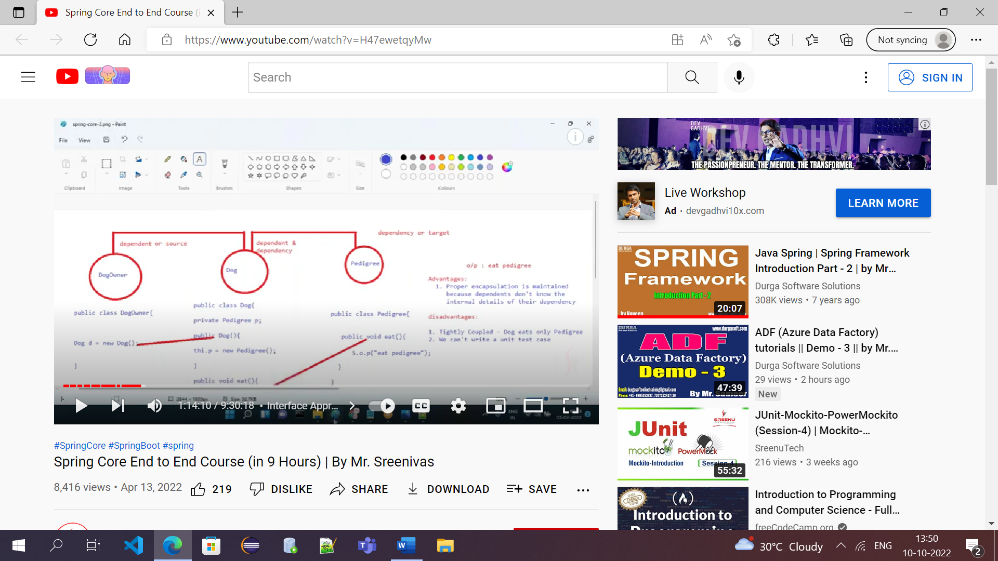

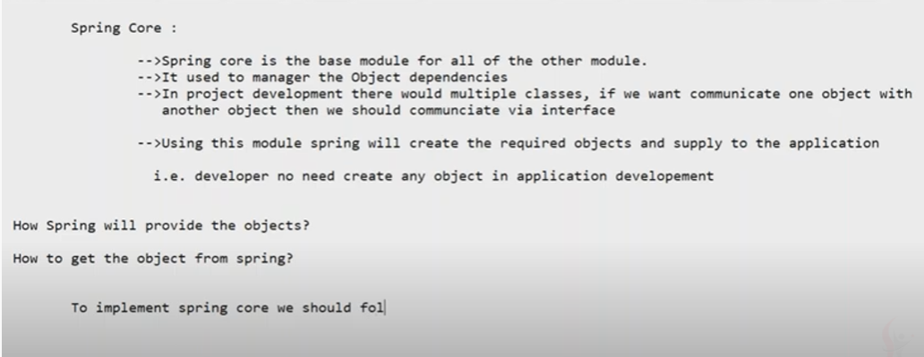

To implement spring core or IOC we must Follow 3 steps:

1.How to Configure

2.How to apply Dependency Injector

3.How to Get the beans and use whenever required

Dependency Injection: The process of creating the object instead of we creating the object the spring will provide object called DI

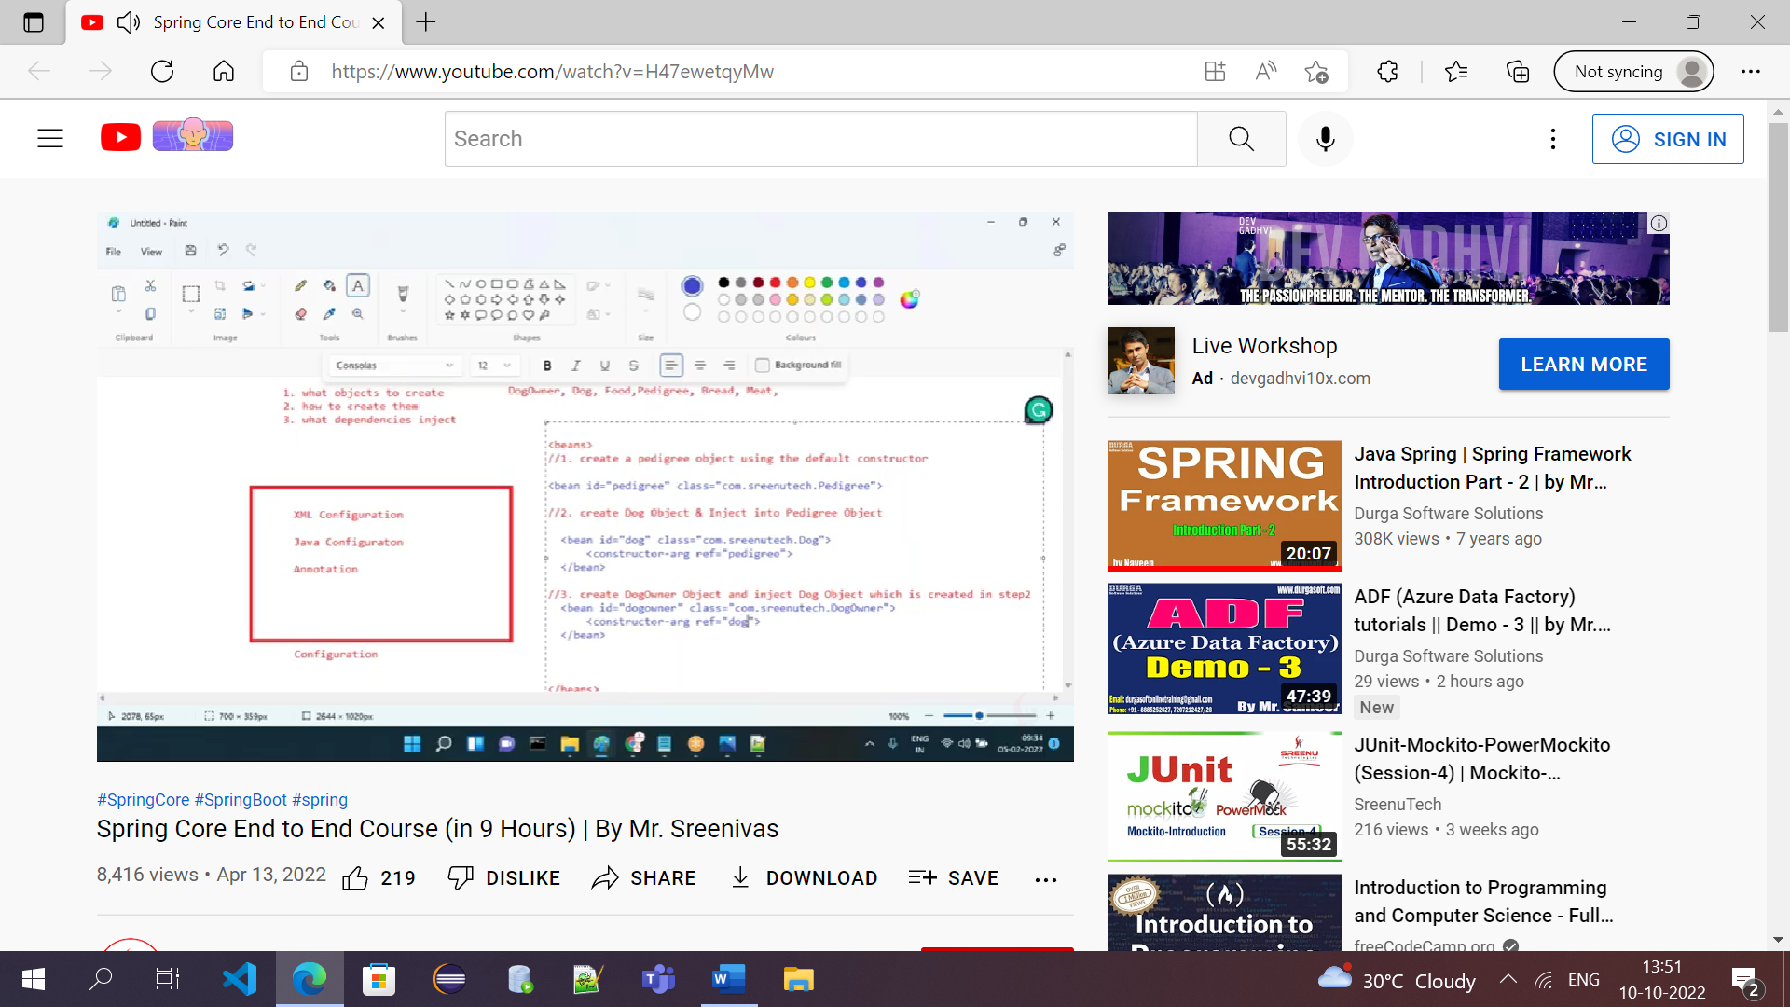

Config -> Dependency Injector(Supply Dependency Injector through Bean Factory)->It will create container called Spring IOC(**Spring IOC** holds all objects references created by Dependency Injector.2.If we want the object get it from container instead of create manually)

BeanFactory factory=new XMLBeanFactory(new ClasspathResource(“spring.config.xml”))

* Dependency Injector will read config and understand what to do
* In IOC pedigree,dog,dog owner

\***IOC** : The logical memory partition created by XMLBeanFactory is called IOC Container and XMLBF returns reference of IOC container as Bean Factory.

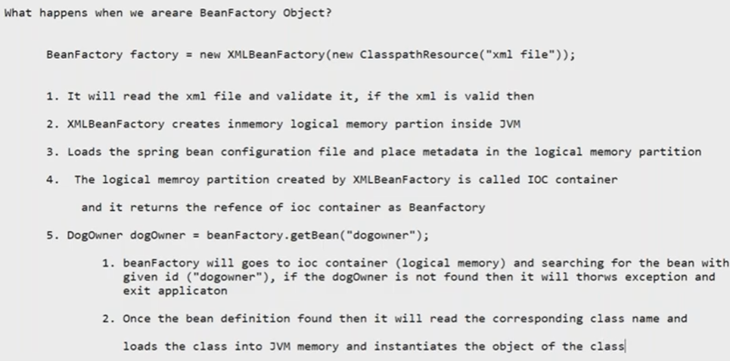

IOC Principle : Managing the dependencies of object & managing the lifecycle(instantiation and destruction of object) is called IOC

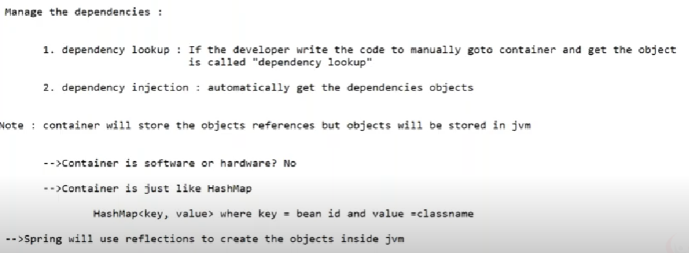

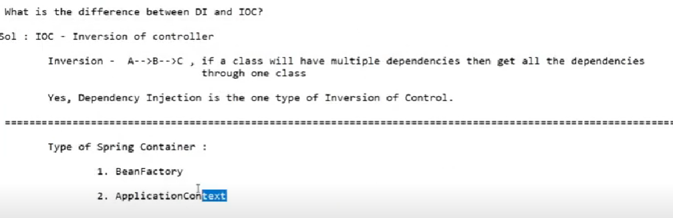

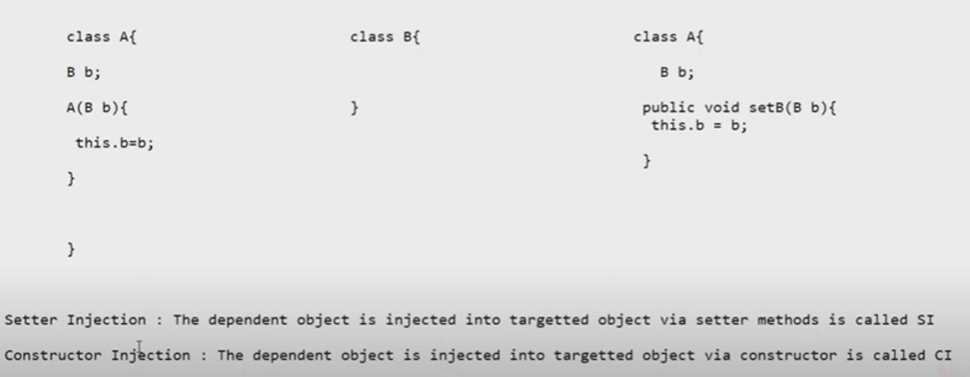

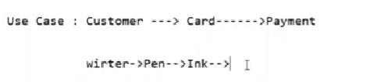

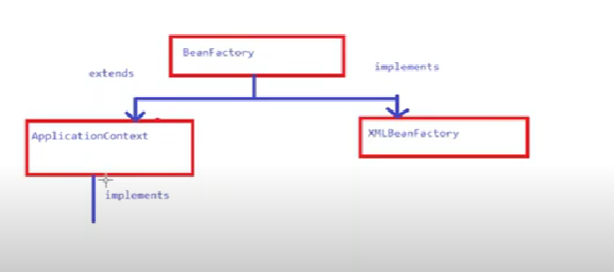

BeanFactory is interface used for standalone applications

AC used for both SA and Web applications

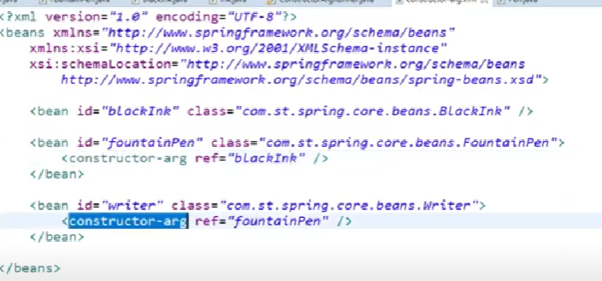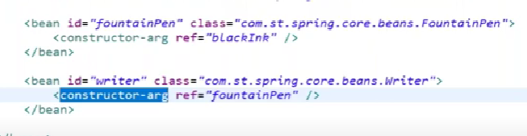

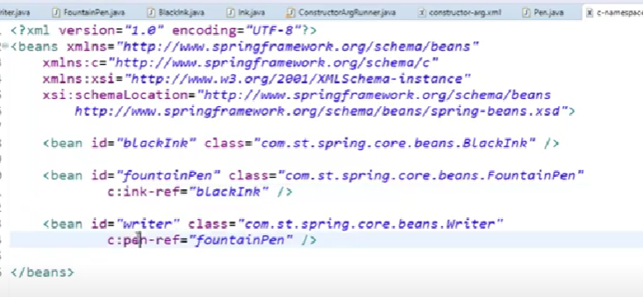

2.40.49 s – setter injection example

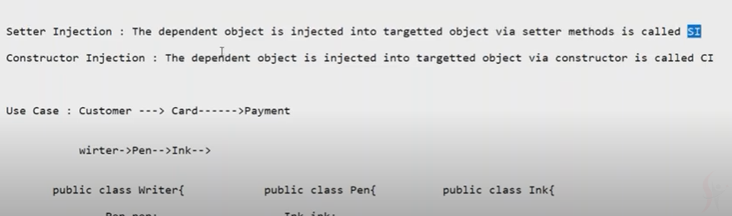

i)XML A)Using constructor,B)Usingsetter

A)If object A dependent on B we use Constructor Injection using XML

B)If A not dependent on B we use Setter Injection using XML

Constructor inj – con arg

Setter inj – property

(Without b, a should not create – validation for point 1

A is dependent on B , B is dependent on A --- validation for point 3)

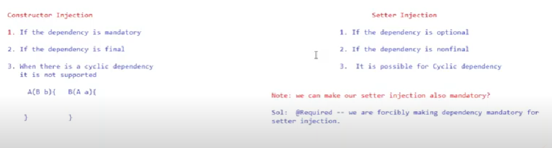

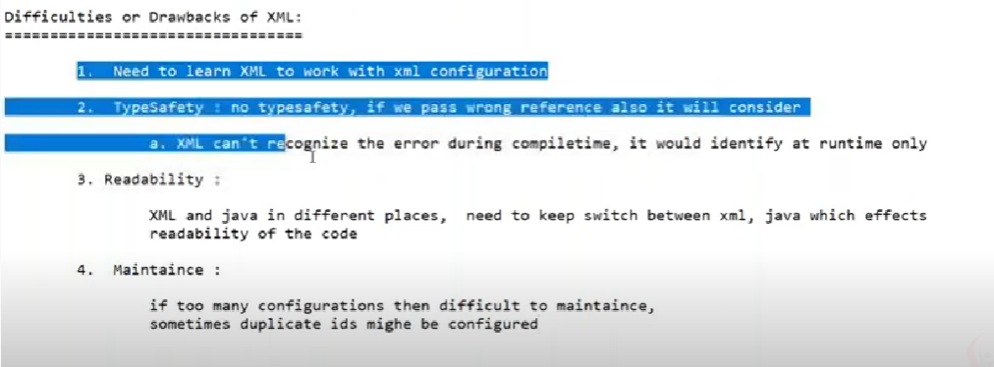

To Overcome these problems we go for java config:

Java Configuration:

//Replace xml with java config

<beans>- @Configuration

<bean id=”” class=””>

@Configuration

public class JavaConfig{

}

Beans replaced with @Configuration

1st bean @Bean

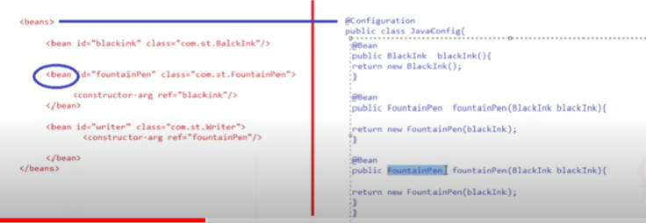

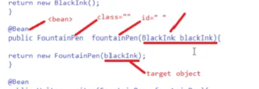

How to load xml file & java config file:

1st xml 2nd java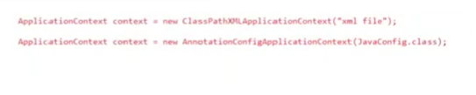

Getting

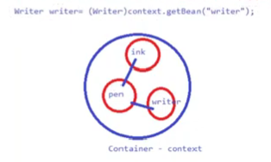

How to apply DI using xml and java config:

For each component writing beans(‘n’ number of beans is difficult)

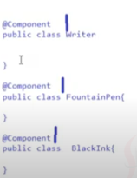

So by using @Component,@Autowired annotation

We can reduce the more configuration code

(@Component – means bean (In XML we write as)

<component-scan basepackage=”com.spring.app”> )

First it will check if there are any component classes.Then it will create object for that)

(@ComponentScan(basepackage=”com.spring.app) --- used in java config

How to apply dependency injection using @Component

Ans:@Autowired is used to inject the target object into source object

@Autowired can inject via constructor,via setter,via field

**How many ways to configure bean in Spring?**

<bean> or @Bean or @Component

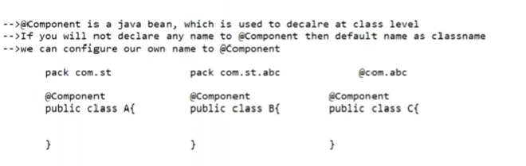

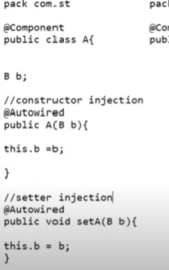 If we give autowired target bean will be injected

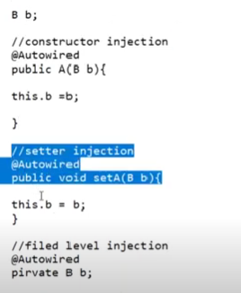

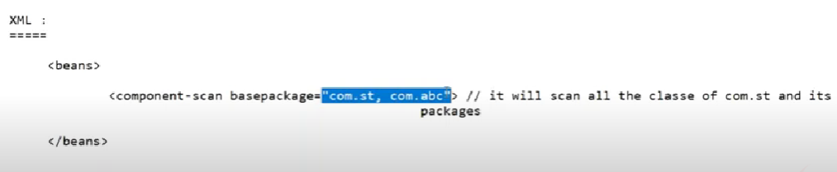child packages

Here com.st means com.st , com.st.abc

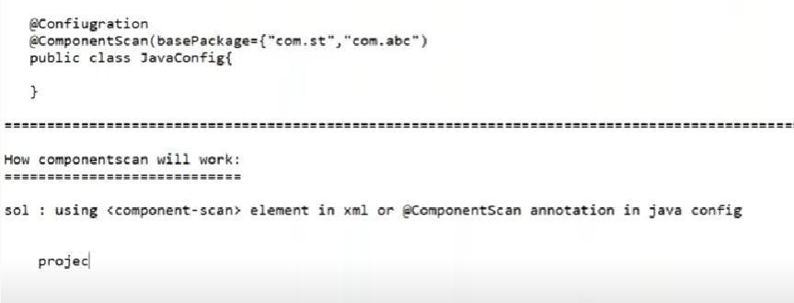

Component,Autowire,Beans

----------------------------------------------------------------------------------------------------------------------------------------------------------------------------------------------------------------------------------------------------------------------------



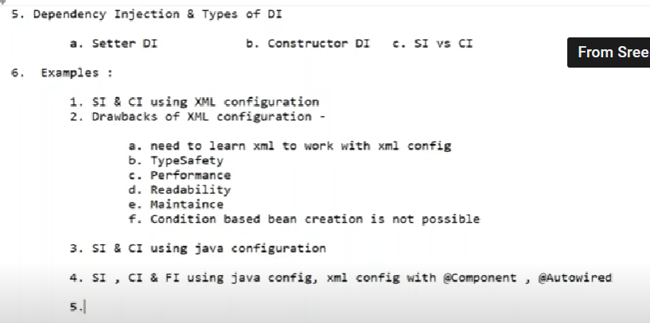

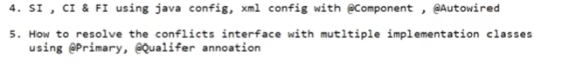

7.Spring Core Annotations

**How to remember Spring Core Annotation easily:**

1.To replace XML with Java Config -@Configuration

2.To replace bean element with bean -@Bean

3.To reduce Config - @Component

4.Spring Knows where there is class representing Component - @Componentscan

5.How to inject beans from container - @Autowired

6.Import xml with Java Config -@ImportResource

7.Doubt ---- Import java config to java config - @Import

8.Resolve Conficts - @Primary,@Qualifier

**Qulaifier – If there are 2 or more beans of same type this annotation is used(on any class annotated with component ) inorder to resolve the conflict.**

**Primary – This annotation is used to give preference to particular bean if there are more beans.**

**DI:**

DI ---XML config –SI,CI -Manual Configuration

----- Java Config -SI,CI -Developer will write config manually

Autowiring – automatic config with help of @Component,@Autowired annotations

@Component – is used to make pojo class as spring bean

@Autowired -is used to create the DI

Autowired -- CI,SI,Field Level Injection ------XML config,Java Config

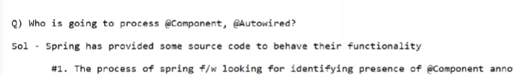

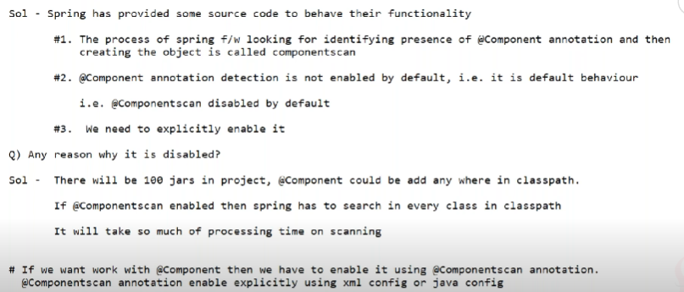

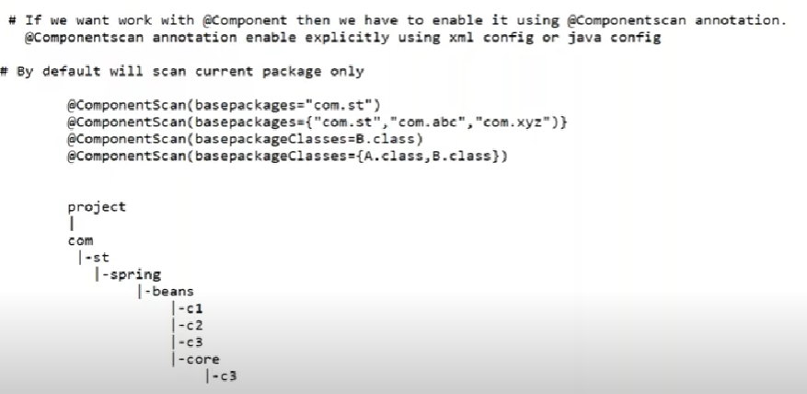

@ComponentScan we can scan for packages(child packages inside a package)

Or Classes using basepackageClasses

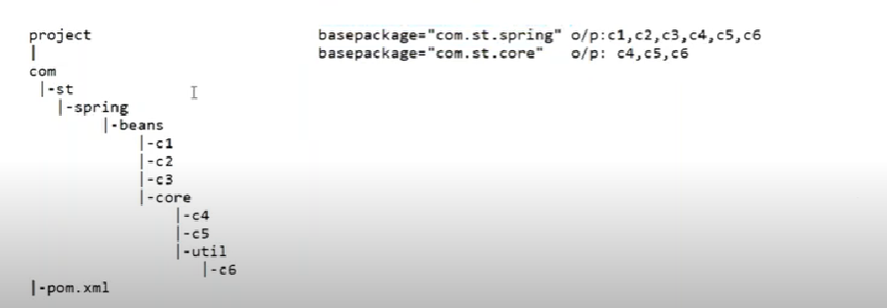

C1,c2,c3 – classes

C4,c5 -child classes of beans(c1,c2,c3)

C6 childclass of core(c4,c5)

**@Retention – Tells the scope of Annotation..whether this(any ex:Configuration) annotation required at compile time or runtime**

**@Retention(RetentionPolicy.RUNTIME) – Runtime here**

[**\*@Target{ElementType.Method,ElementType.ANNOTATION_TYPE}**](mailto:*@Target%7bElementType.Method,ElementType.ANNOTATION_TYPE%7d)**)**

**Annotation will be used for method here(Ex:field level,constructor level)**

**Most annotations used at runtime**

**\*Field level internally use Reflections concept**

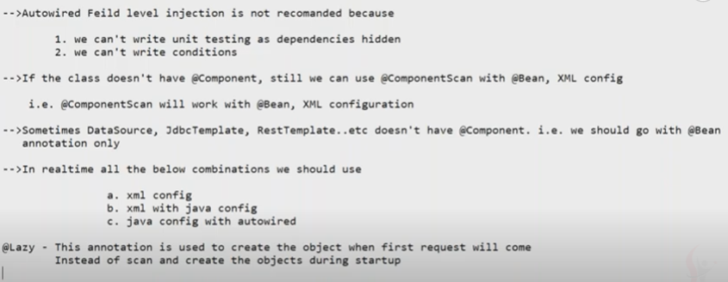

**Lazy introduced in spring 3.0**

**@Lazy – It will create object at the first request instead of at the starting only**

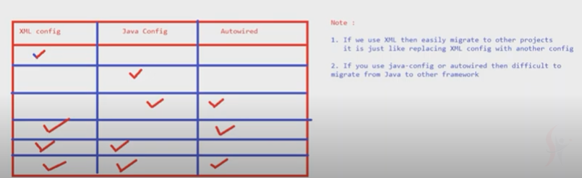

**Can use xml config alone,java config alone but not autowired**

**Java+auto possible**

**Xml+java**

**Combi of xml+java+auto possible**

**\*@Primary – It will give priority to one bean than another beans**

**-can’t use primary for more than 1 bean,i.e., its like switch statement ,default bean it will give**

**-If you are not sure what is default then don’t use @Primary annotation**

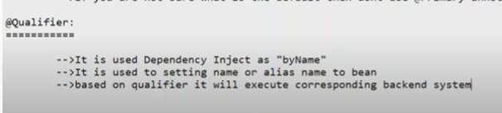

\*\***Based on qualifier it will execute corresponding backend system**

**Example**

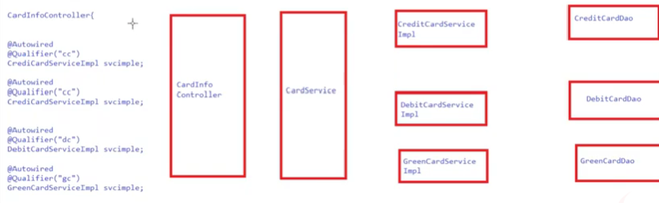

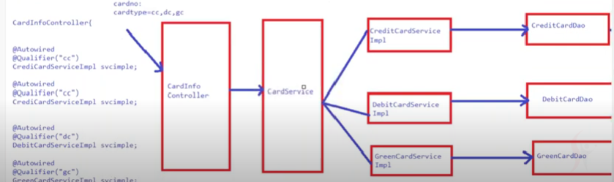

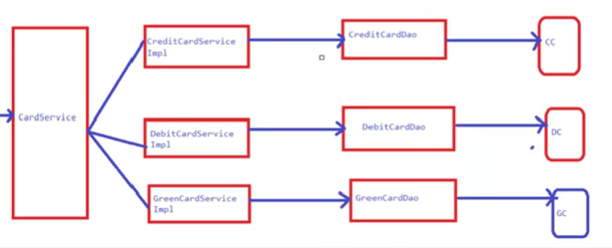

**Bean Scope:**

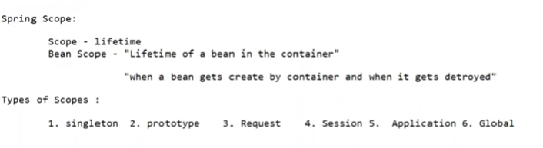

**Singleton** –

It creates single object and handles multiple request

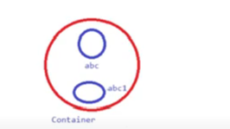

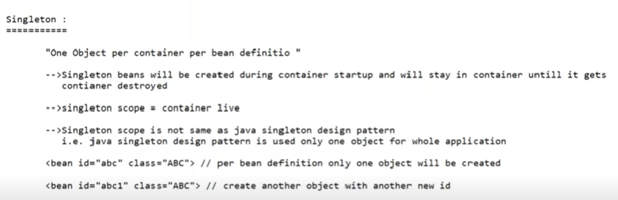

If we use same bean and for different methods, hashcode will be same

Diff bean diff hashcode will be created

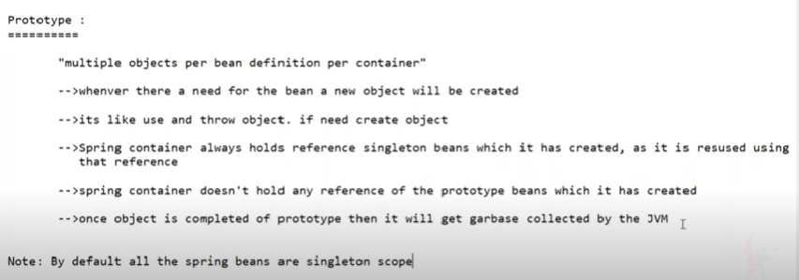

Even diff methods in same class when we declare prototype ,it will show diff hashcode

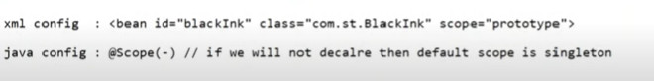

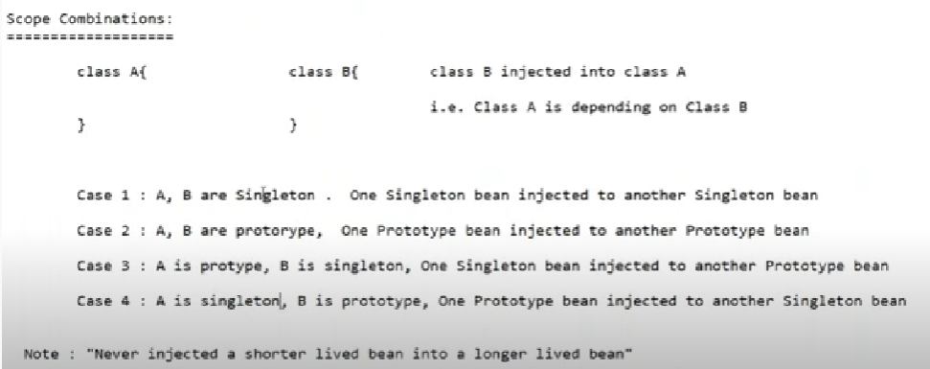

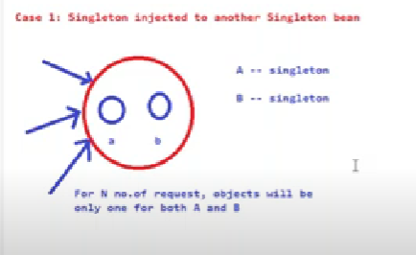

Only 1 object created for A,1 object for B irrespective n number of request

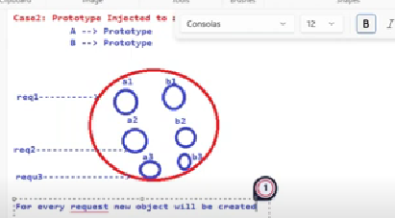

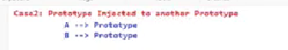

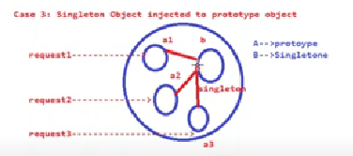

Every request new object created for a like a1,a2,a3 and b object is only 1 bcz of prototype

A1 talk to b to get data

Similarly a2,a3 talk to b to get data

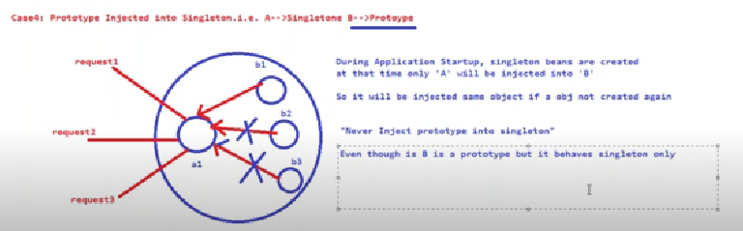  
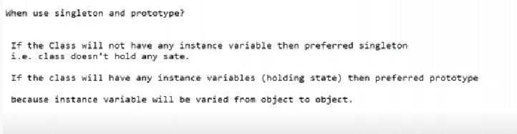

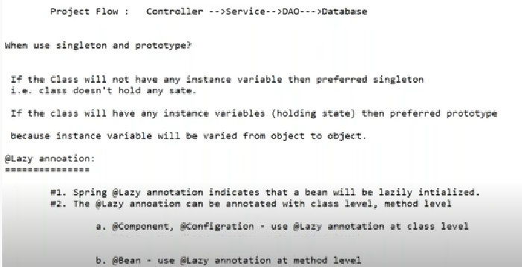

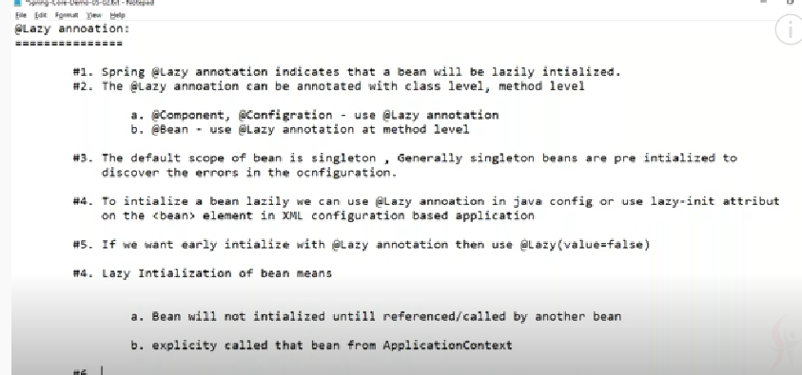



7.05.49

@Lazy(value=false) it will not create lazy for that class

How to load properties file

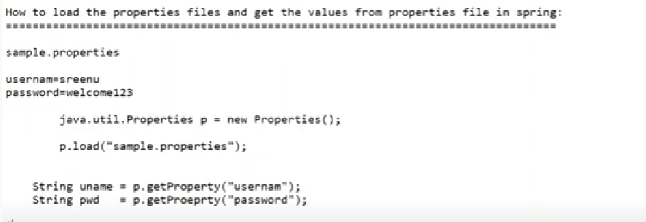

Instead of writing all the code there is an annotation called @PropertySource //is used to load properties file

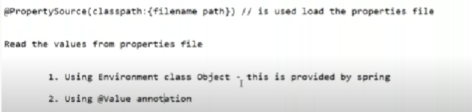

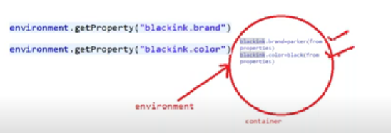

It will load and get property

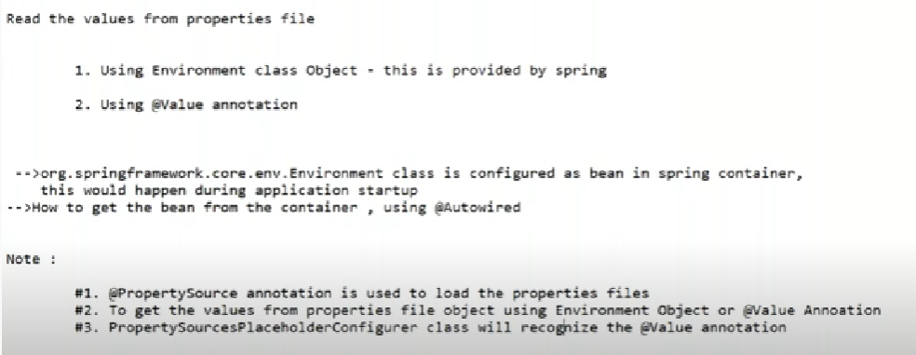

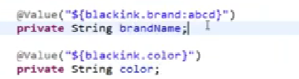

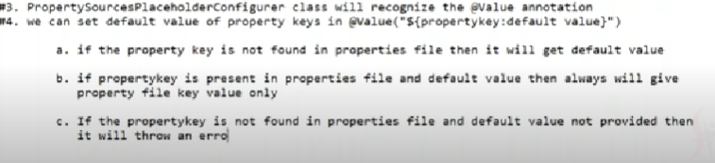

Error

Userdefined classes we can write- @Component

Predefined we use - @Bean

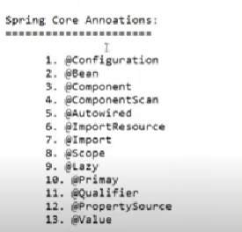

Propertysource – to load properties file

Value – get values

Setter injection – name,value

<beans>

<bean id=”Employee” class=”com.spring.test1.Employee”>

<property name=”empid” value=”111”/>

<property name=”age” value”60”/>

<bean>

</beans>

Constructor injection – type,value

<beans>

<bean id=”Employee” class=”com.spring.test1.Employee”>

<constructor-arg type=”int” value=”111”/>

<constructor-arg type=”String” value”60”/>

<bean>

</beans>

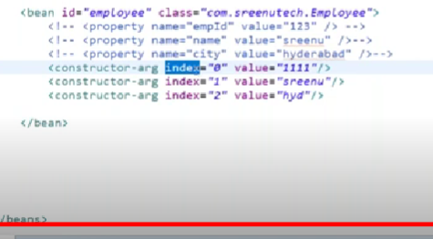

Alt+SR ,Alt-A –these commands in eclipse used to generate getters and setters

**How to load the properties file based on environment ?**

Sol: In realtime we will have different environments or profiles

How any Project works from starting to ending?

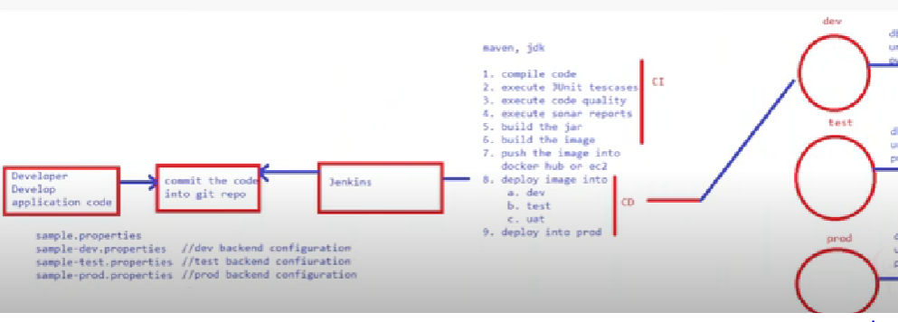

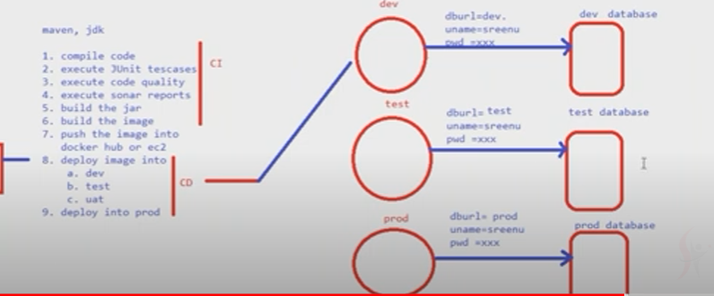

Developer develops code and sent tot git repo..Jenkins fetch data from git repo

Then 9 steps will be done.(after that dev,test,prod will fetch credentials like username,password for each of them respectively and deployment done.)

Foe ex if we deploy into dev it will fetch data(creadentials) from database and perform deployment

Similarly for others…!!(test,prod)

**How to find the environment based properties file without spring:**

configure profile name (dev,test,prod) inside server configuration

catalina.properties

environemnt-dev

during application startup, all the value will be set to JVM

**System.setProperty("environemnt",dev);**

**Application code :**

String env= System.getProperty("env"); --this is manual code . spring developed annotation profile instead of writing all these code //@Profile

String filename = "sample-"+env+".properties"

java.util.Properties p = new Properties();

p.load("sample.properties");

String uname = p.getProperty("usernam");

String pwd =p.getProeprty("password");

-->@Profile annotation is used to get the environment value from the jvm which was setted during application startup

Examples :

‒‒‒‒‒‒‒‒‒‒

1. environments or profiles dev, test, uat,prod

**2. how to load envionrment based properties file**

**Sol: Using @Profile annotation**

3. **If it is standlone application, we have to set the envionment using the below options**

**\*\*a.System.setProperty("environment", "dev") --Legacy**

**\*\*\*\*b. spring.profiles.active=dev --Using Spring**

If it is **web application,** we have to set the environment at server level

Tomcat : catalina.properties ==> spring.profiles.active=dev

Jboss :server.xml ==> spring.profiles.active=dev

If we use docker then set the enviornment name inside docker file

whenever we set the environment value, during application startup it would be set to jvm

Q)How to get the values from JVM?

1. String env =System.getProperty("environment")

2. Using @Profile annoation, this will use internally System.getProperty() annotation only

-->@Profile annoation is used at class level, method level

a. if @Profile will use at class level then no.of profiles = no.of configuration classes

b. if @Profile will use at method level then one configuration class which contains

no.of profiles = no.of methods (each method will take care to load each profile properties file)

----other way to run

Rc-config-env-spring.profiles.ctive – down give name qa -exe

Annotations

@ImportResource – Inject xml into java

@Import – one java config file import to other

@Qualifier

@Scope-starting only we need to

@PropertySource – to load properties file

@Value- get value

@Profile (these are spring annotations)

15.@Required – to make setter injection mandatory

[16.@Named](mailto:16.@Named) – (<bean> or @Bean or @component)

[17.@Inject](mailto:17.@Inject) - @Autowired (16,17 are java annotations)

**Spring Core Annoations:**

1. @Configuration

2. @Bean

3. @Component

4. @ComponetScan

5. @Autowired

6. @Import Resource

7. @Import

8. @Primary

9. @Qualifier

10. @Scope

11. @Lazy

12. @PropertySource

13. Value

14. @Profile

15. @Required to make setter injection also mandatory, on top of setter methods you should declare

@Required annoation, so that for setter also dependency was mandatory

16. @Named (<bean> or @Bean or @Component )

17. @Inject @Autowired

Examples :

1. CI using XML config

2. SI using XML config

3. CI using java config

4. SI using java config

5. Import XML config with Java config

6. Import Java config with java config

7. Integrate xml config, java config with java config

8. How to resolve the ambiguity using @Primary, @Qualifier

9. Scopes (singletone, prototype) using java config

10. Scopes (singletone, prototype) using autowired

11. Scopes (singletone, prototype) using xml config

12. @Lazy annoatation examples

13. primitive, collection exmples

14. How to load properties files using xml

15. How to load properties files using java config

16. How to load properties files using autowired

17. profiles using class level

18. profiels using method level

19. profiles using server level

20. profiels using xml and java config

-import javax.inject.Inject; --These are j2ee annotations packages

import javax.inject.Named;

@Named – in place of component we use this in j2ee

@inject – where ever autowired is there we can use inject instead in j2ee

-------------------------------------------END--------------------------------------------------------------------